AI SMART GLASSES PARTS

- GY- 521 MPU 6050
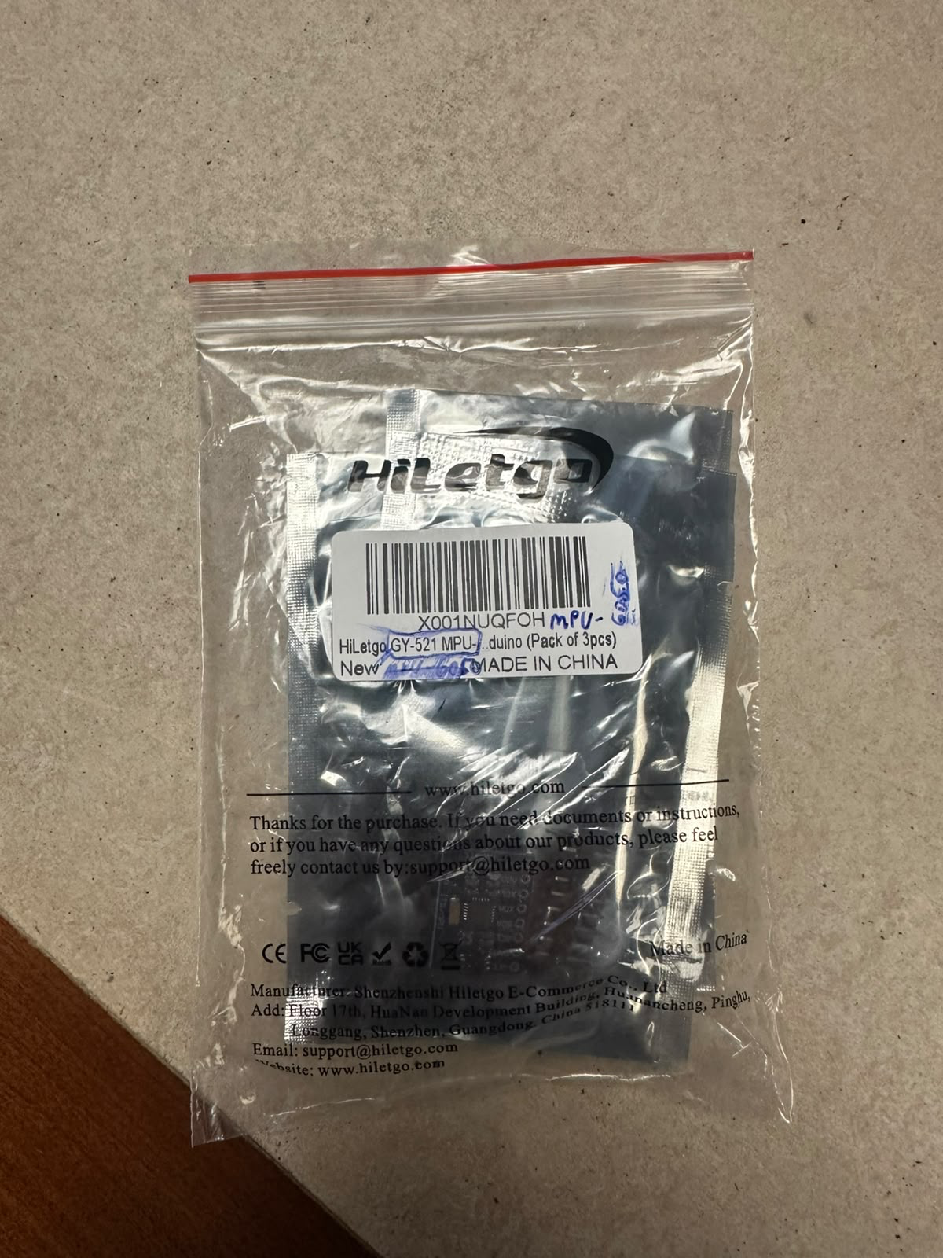

- MAX98357 I25 amplifier breakout
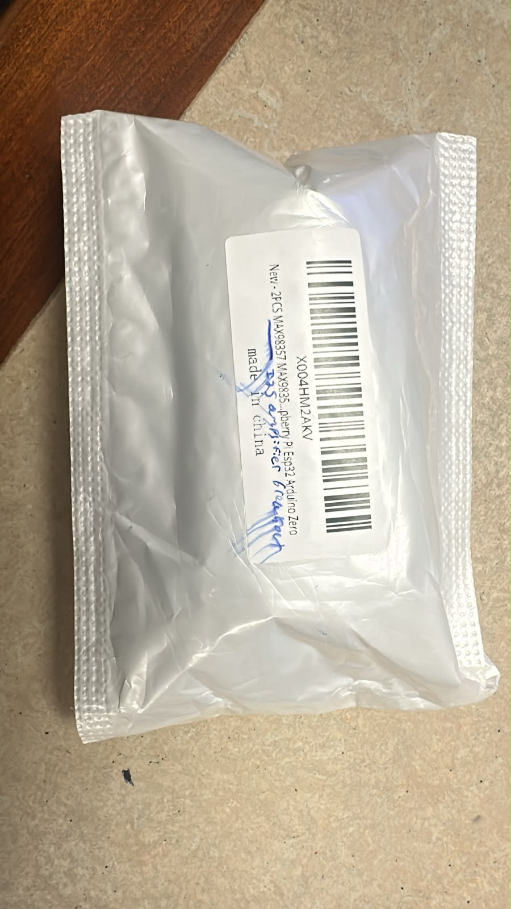

- Tactile Switch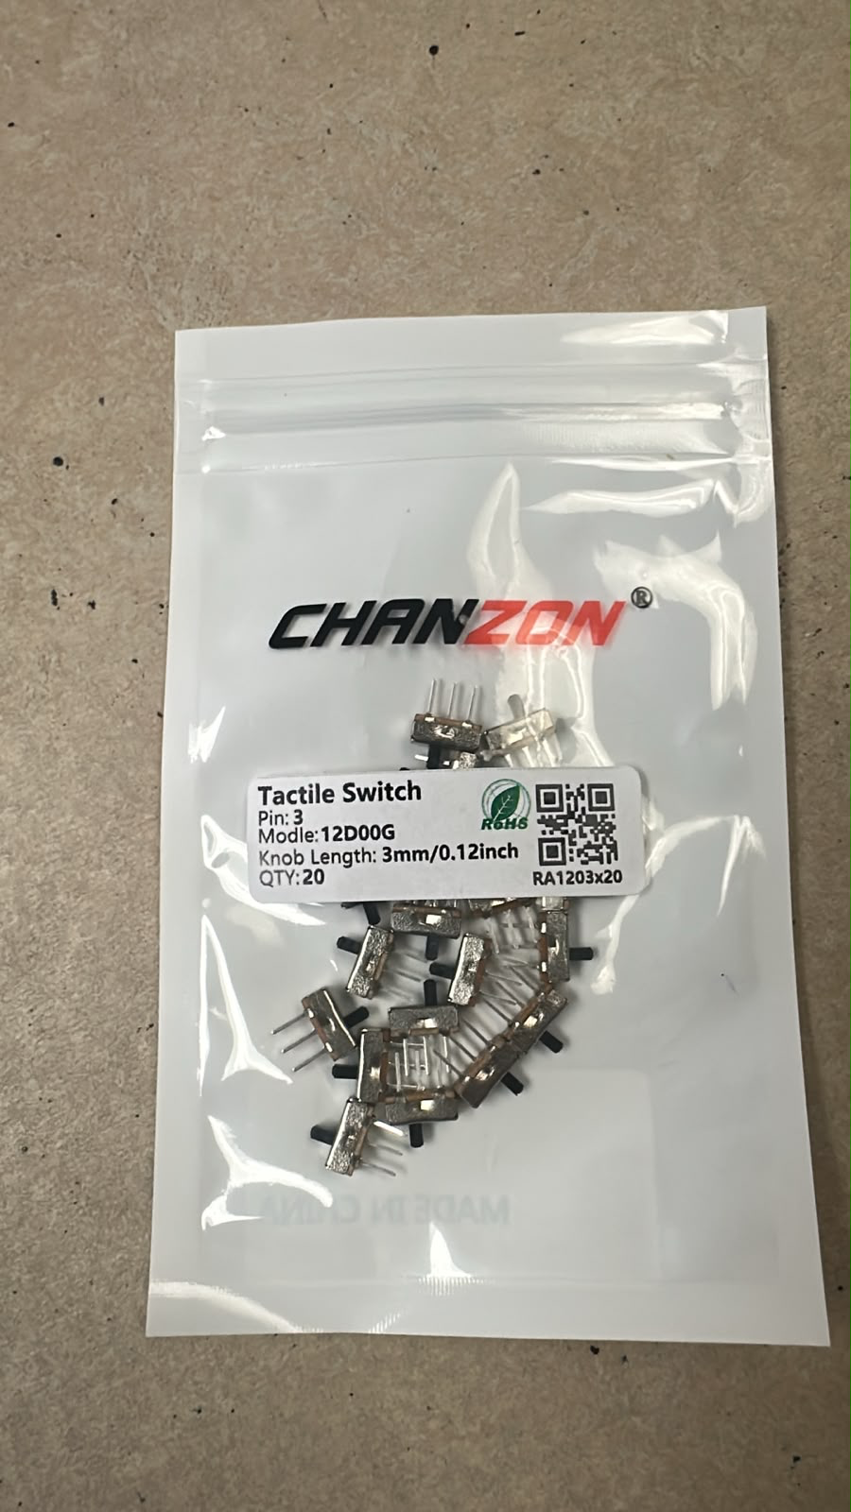
- MT 3608 C boost converter
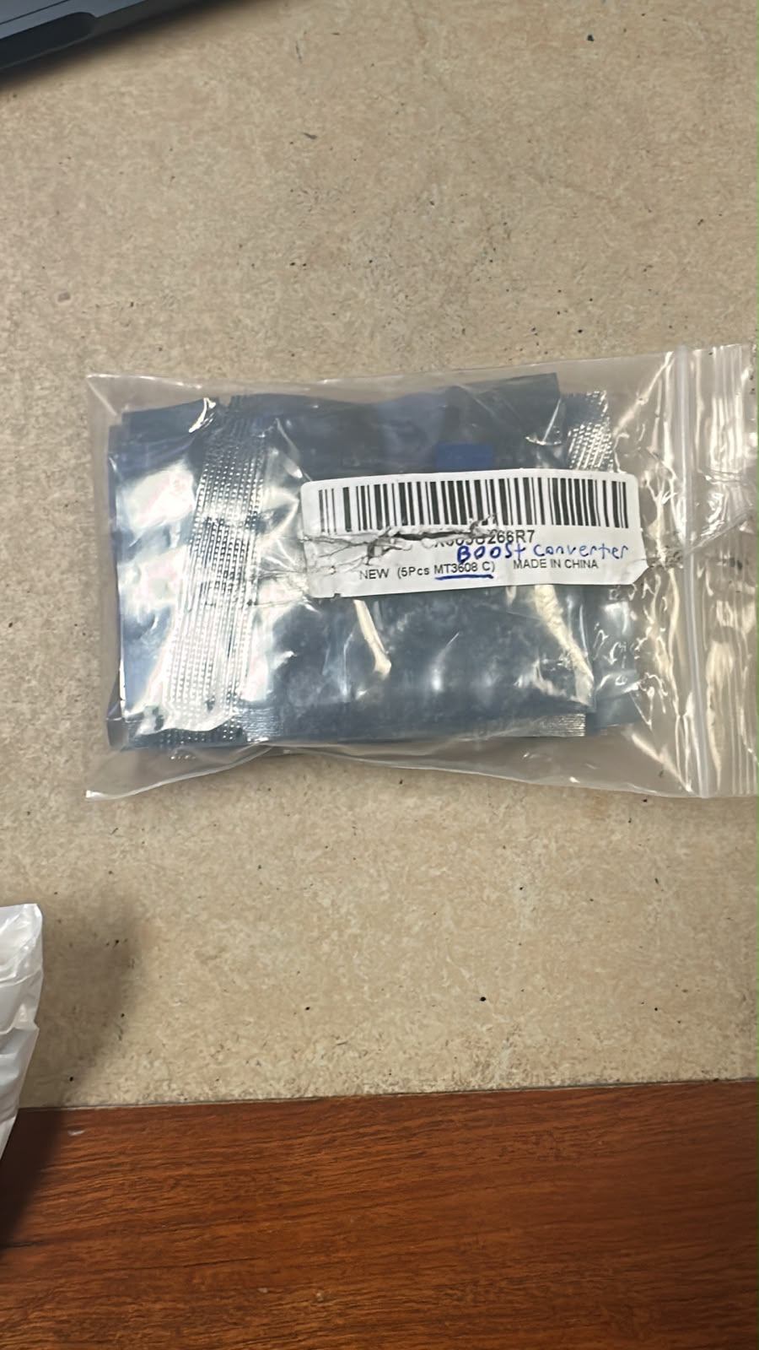
- 0.96 inch oled display
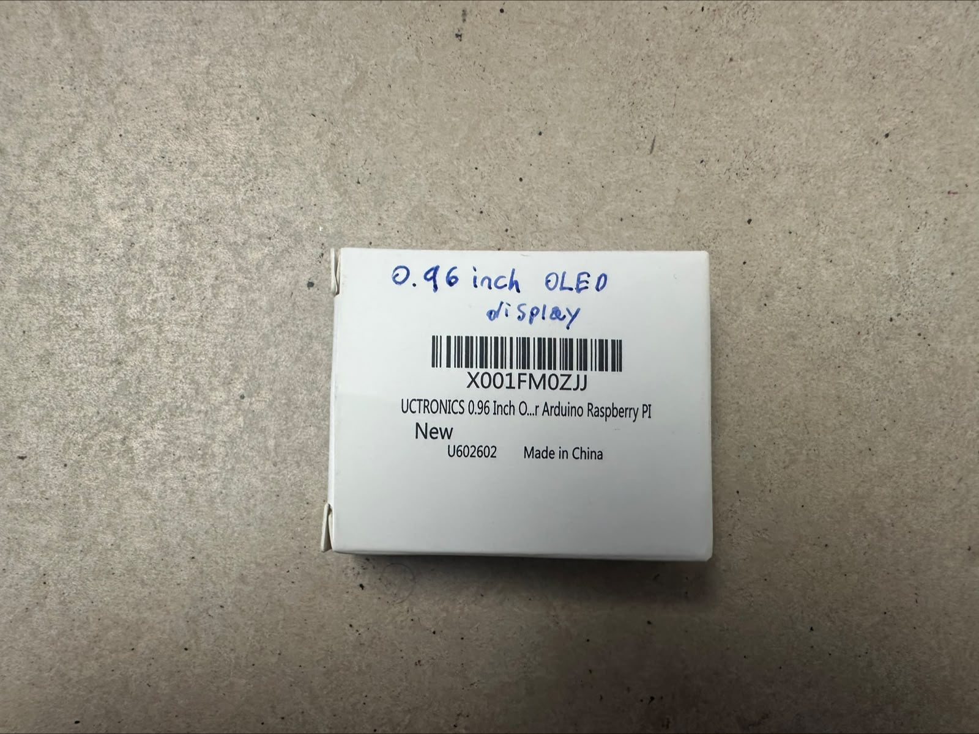

6.Rasberry pi Zero 2w
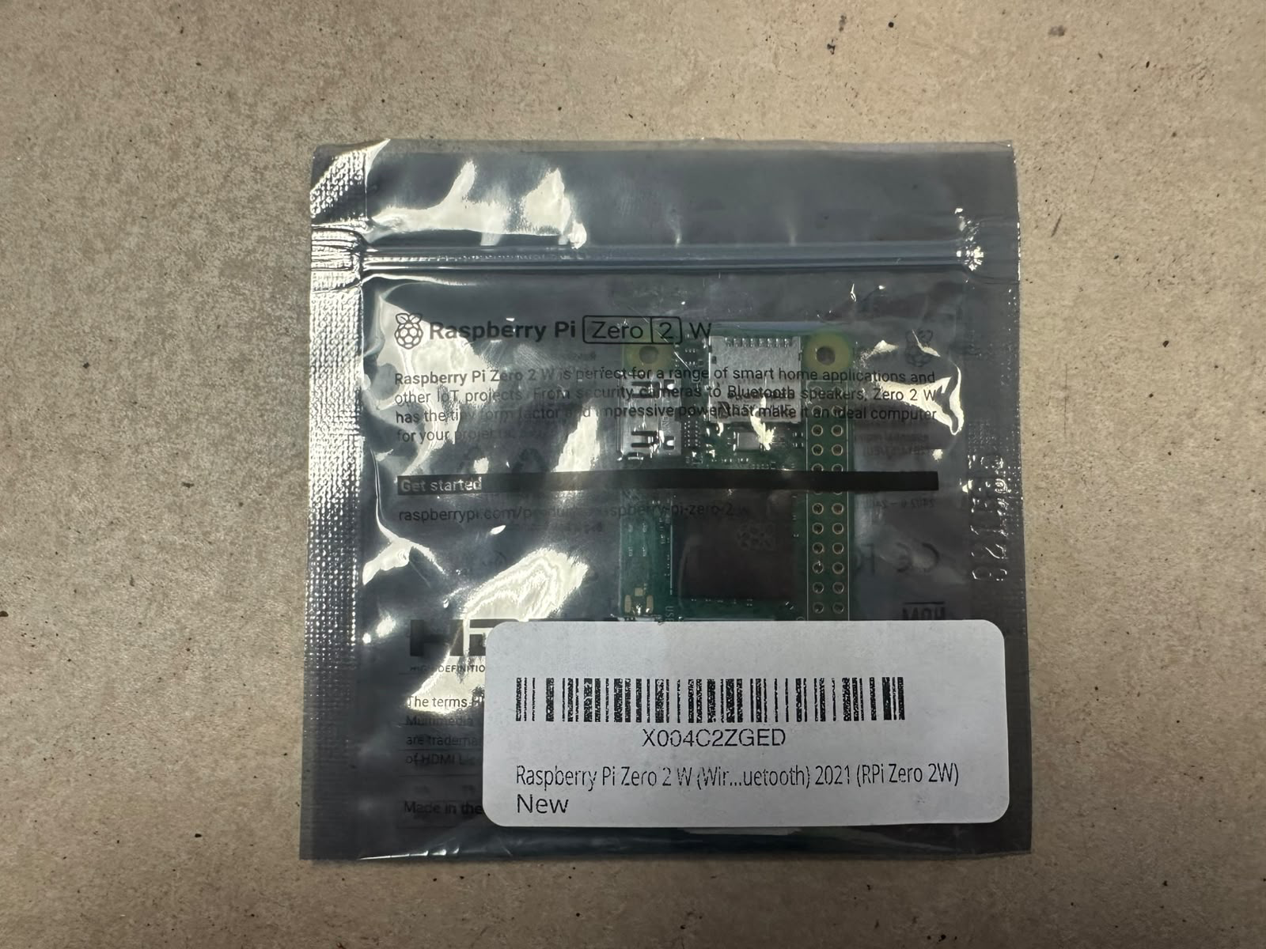
7. 4 pin (2packs)
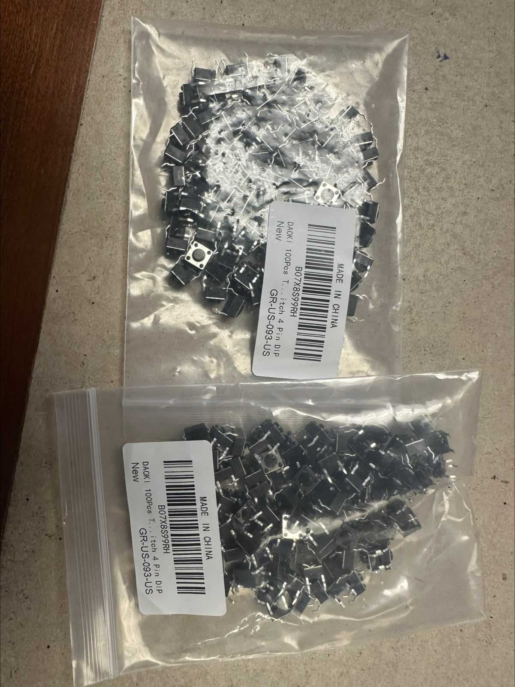
8. Lithium ion battery
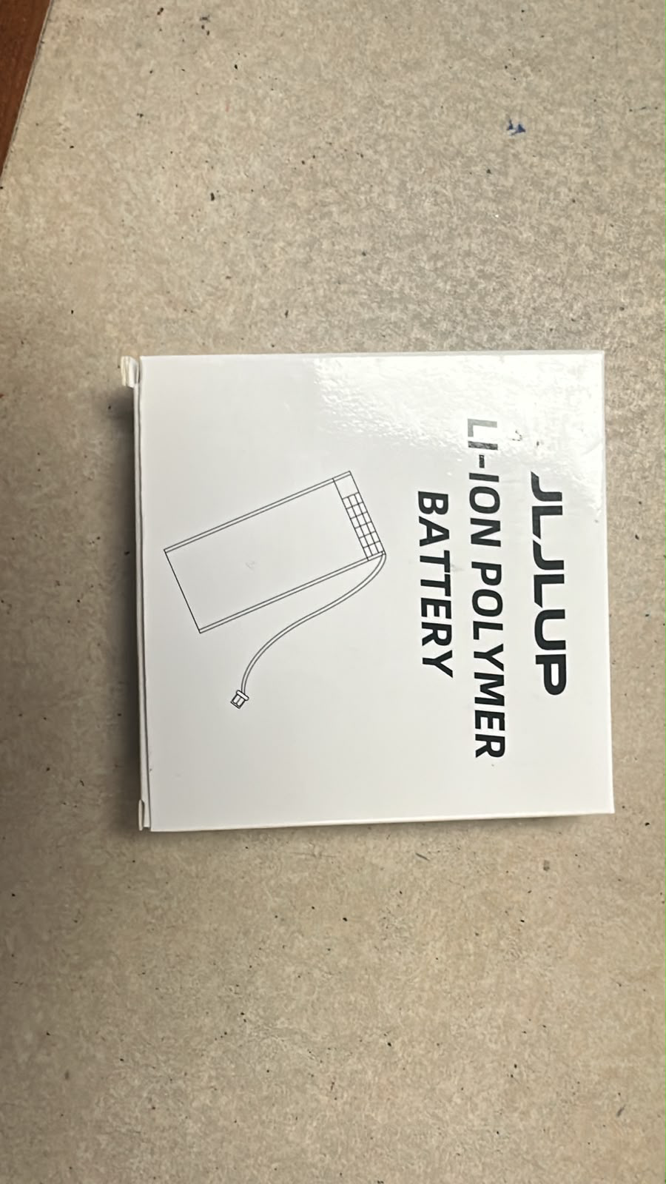

9.1200pc socket head bolts assortment kit
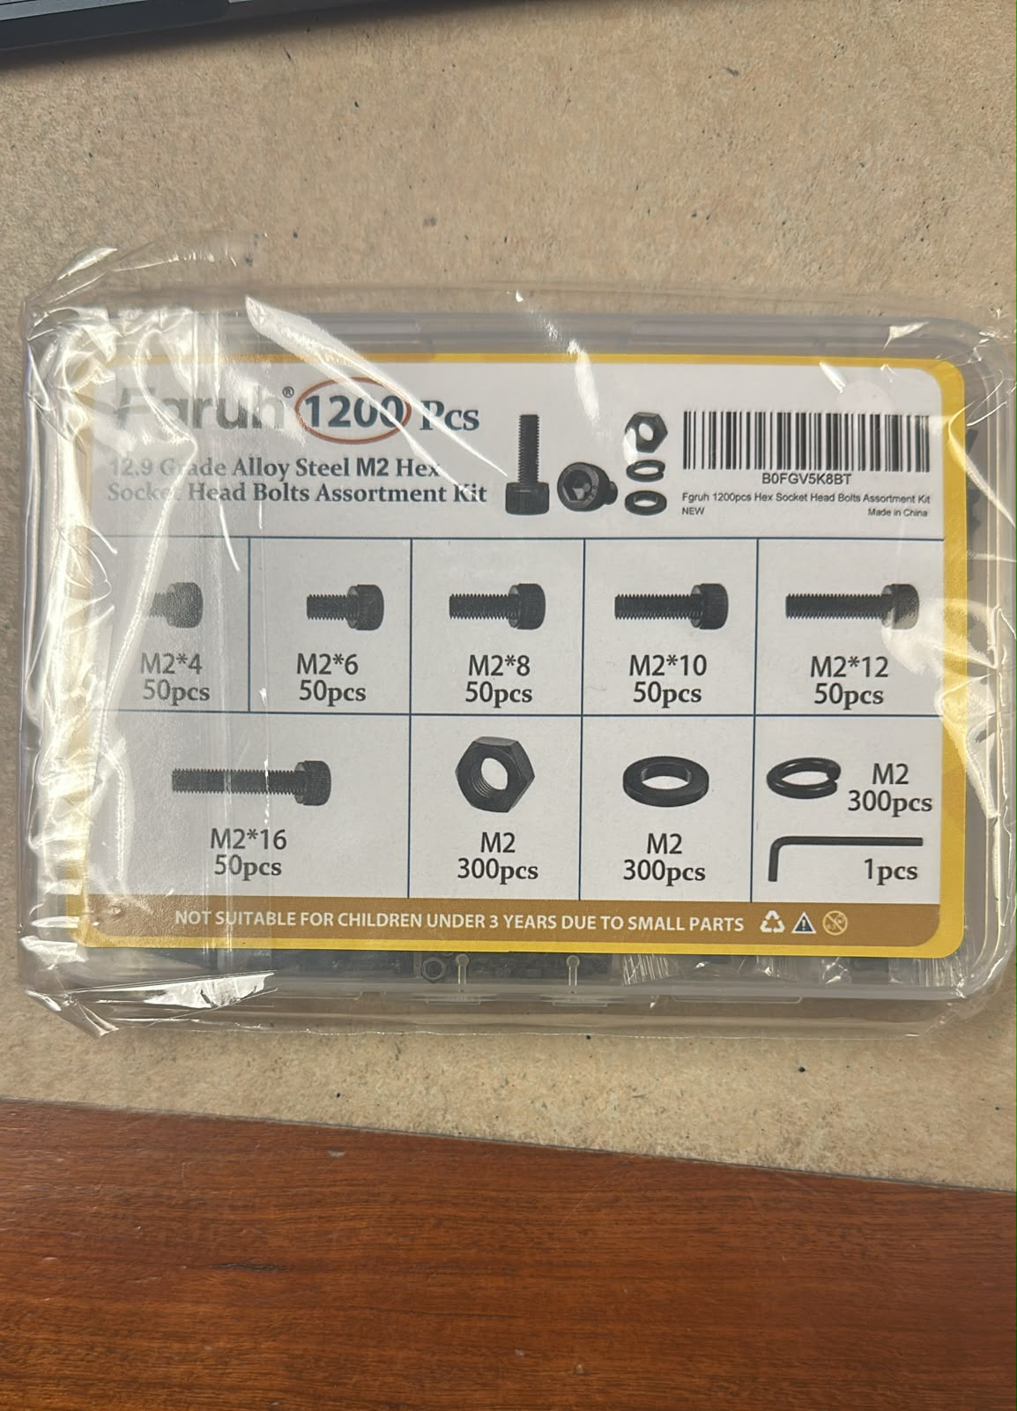
10. Fpc cable
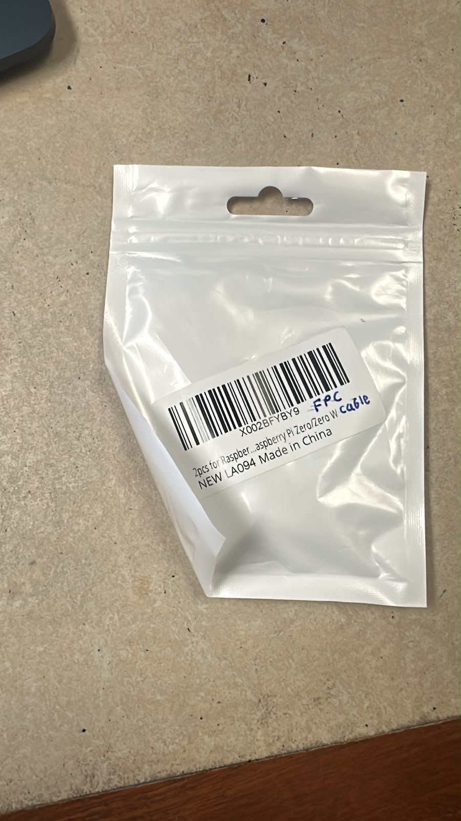
11. Pi zero quick plug
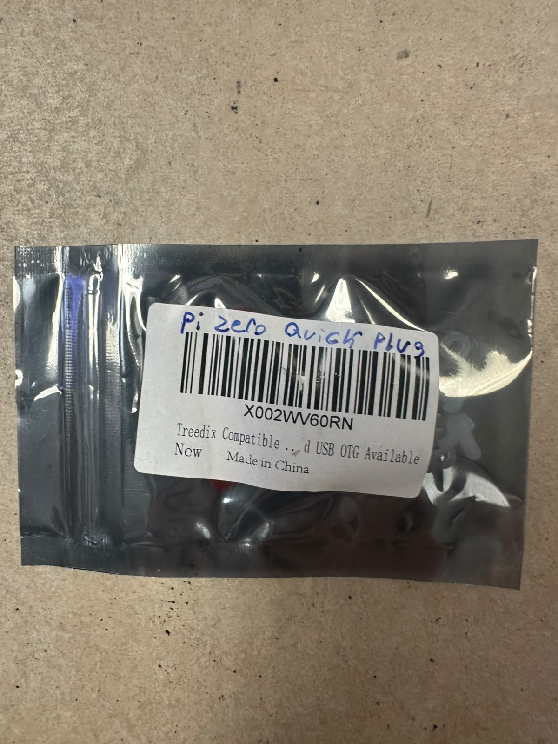

12. ArduCam and digitalmic for microcontrollers
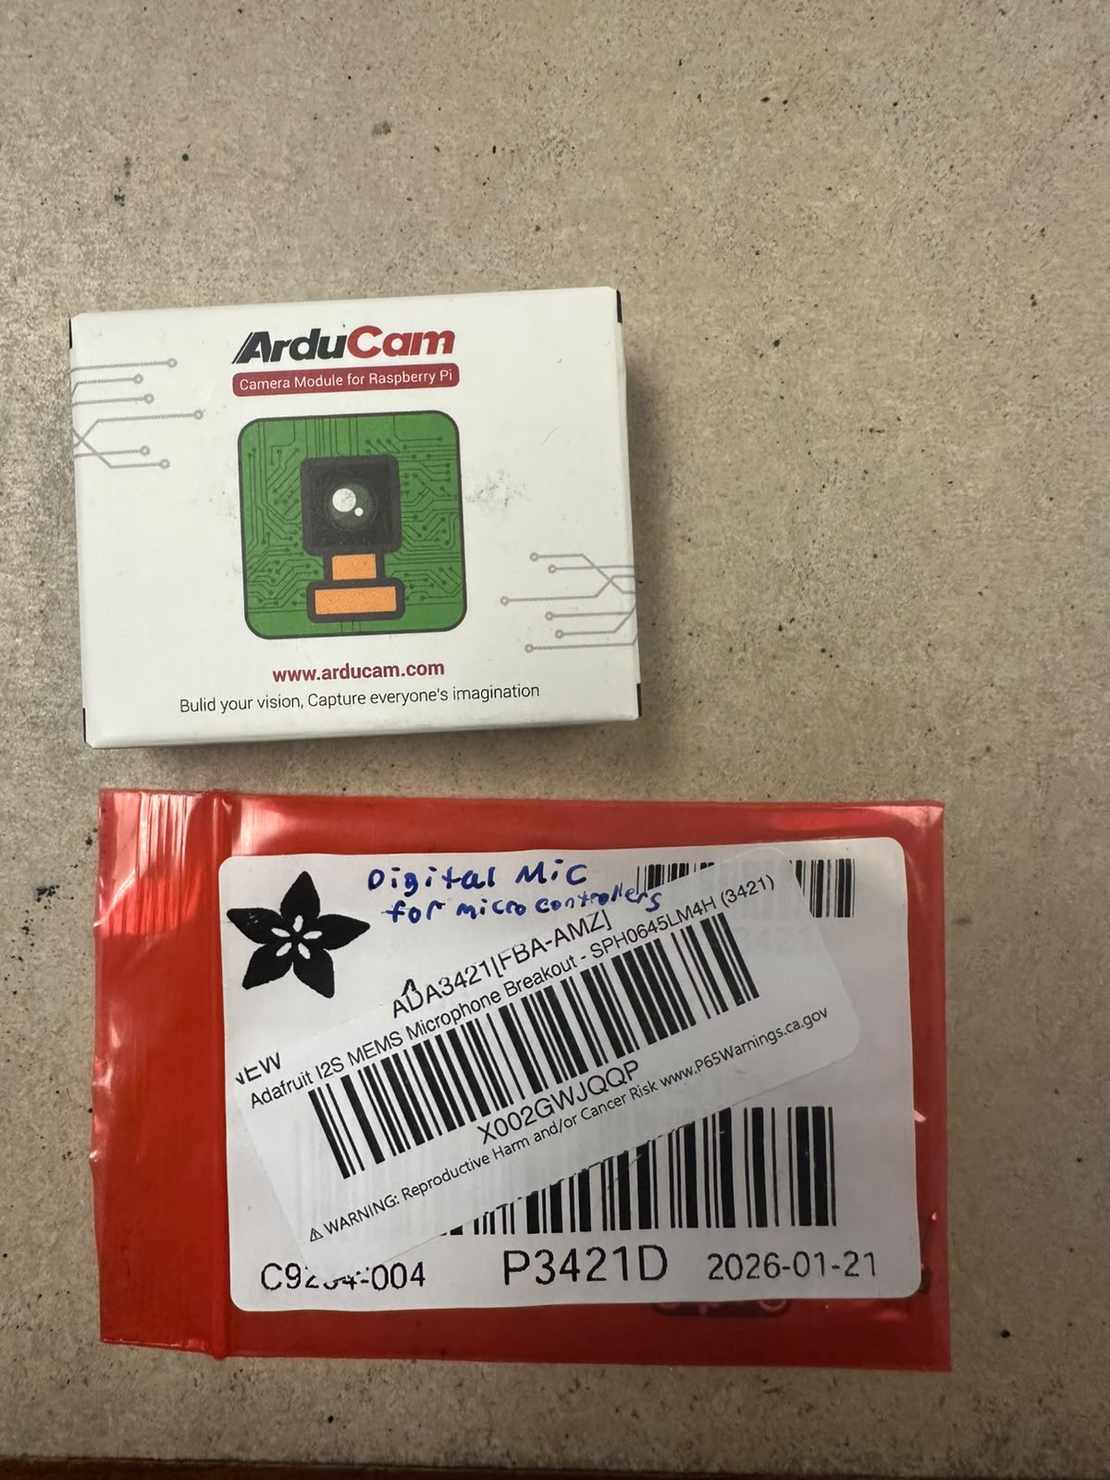

13. Breadboard and Wires
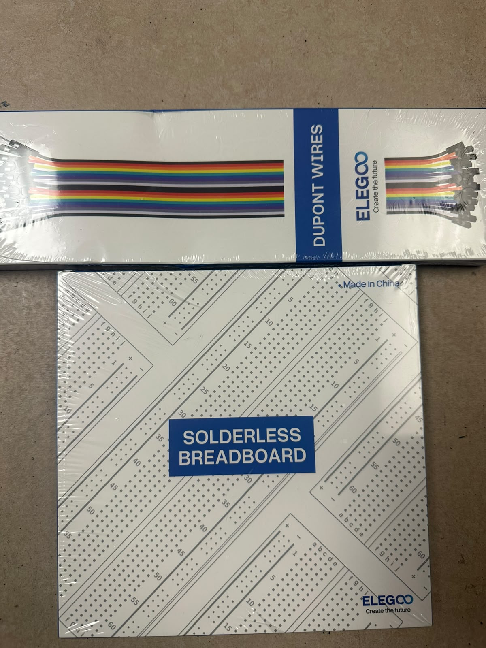

14. SanDisk Micro sdxc uhs-I card with adapter

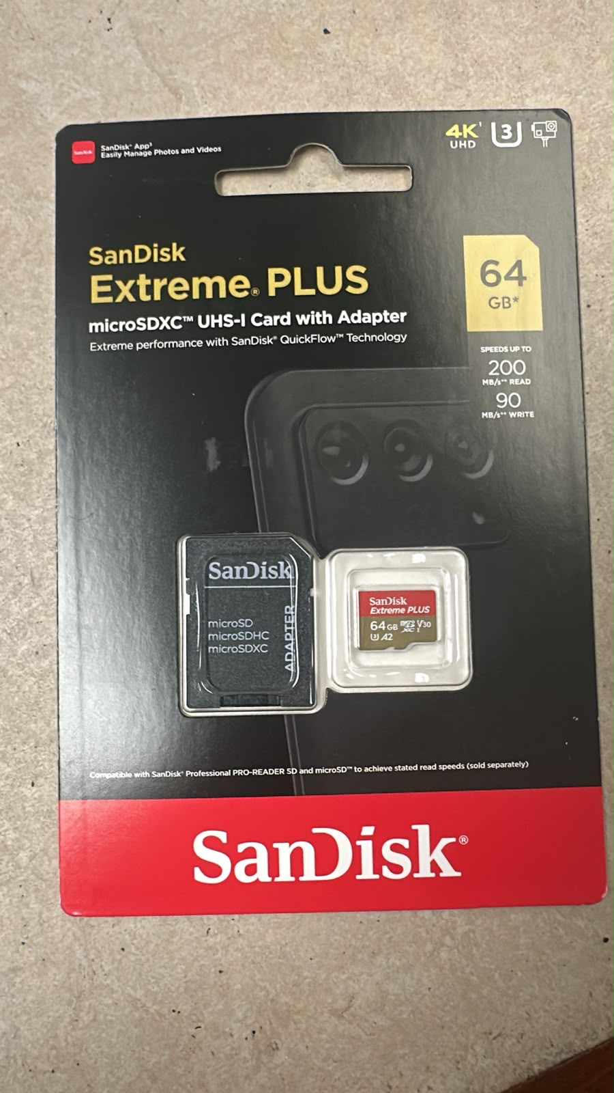

15. Vapor phase corrosion inhibitor and raspberry pi 4 heatsink kit


